# CS 255 System Design Document Template

## UML Diagrams

### UML Use Case Diagram

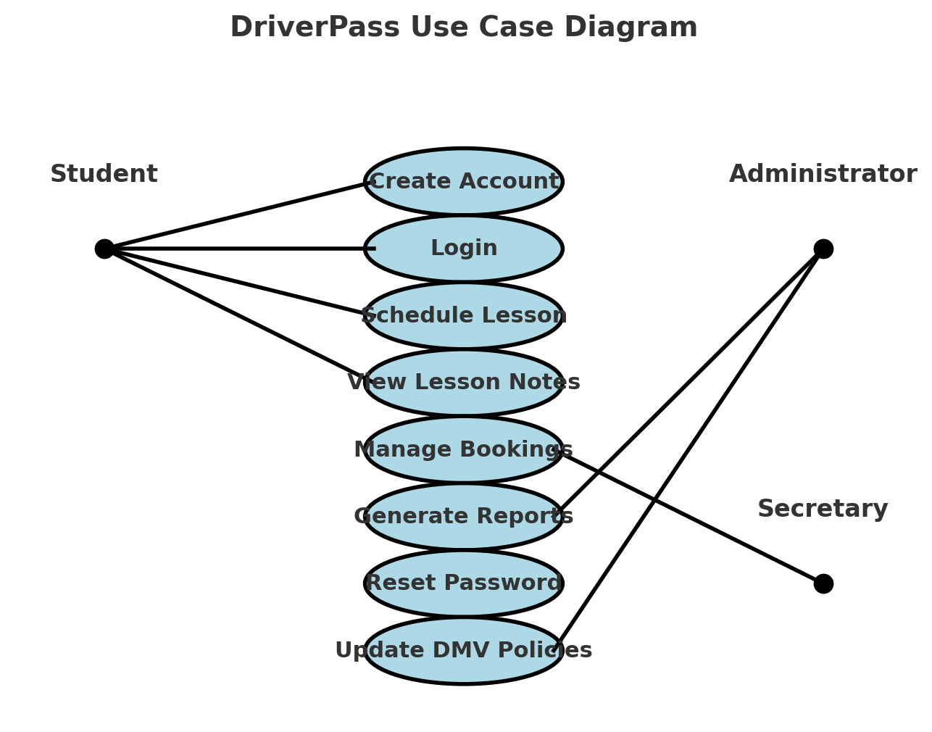

This diagram illustrates the key interactions within the DriverPass system. The main actors include **Students**, **Administrators**, and **Secretaries**. Students can create accounts, log in, book lessons, and view lesson notes. Administrators manage bookings and reports, while Secretaries assist with scheduling. The diagram below showcases these interactions visually.

### UML Activity Diagrams

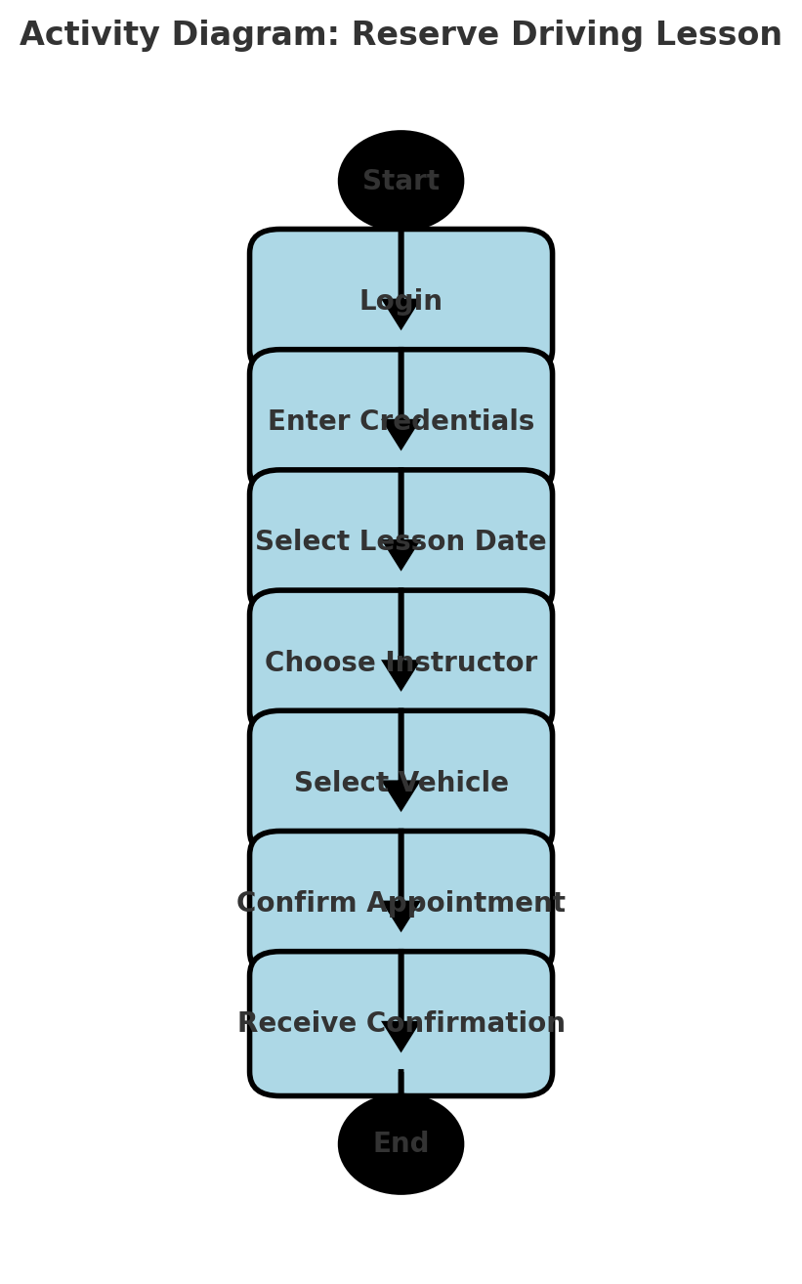

This diagram details the process a student follows to reserve a driving lesson, including logging in, selecting a date, picking an instructor, choosing a vehicle, and confirming the appointment.

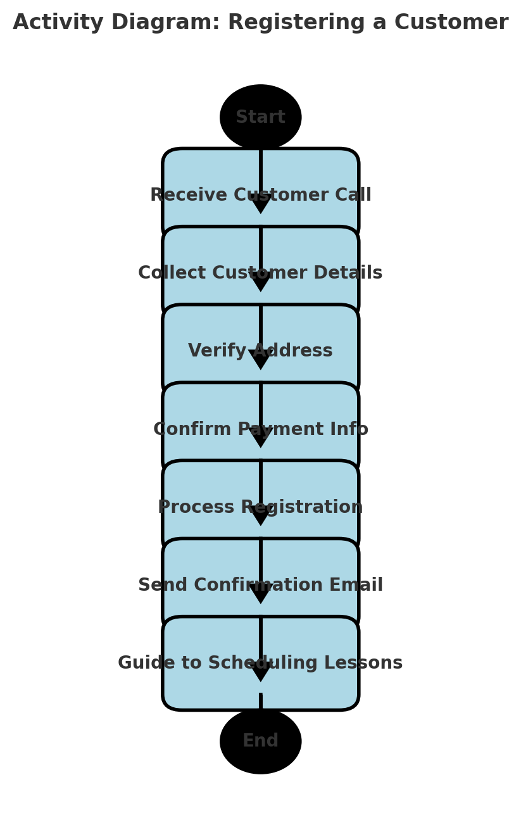

This diagram represents the steps taken by an administrator to register a customer, from receiving a call and collecting details to confirming the registration and guiding the customer toward lesson scheduling.

### UML Sequence Diagram

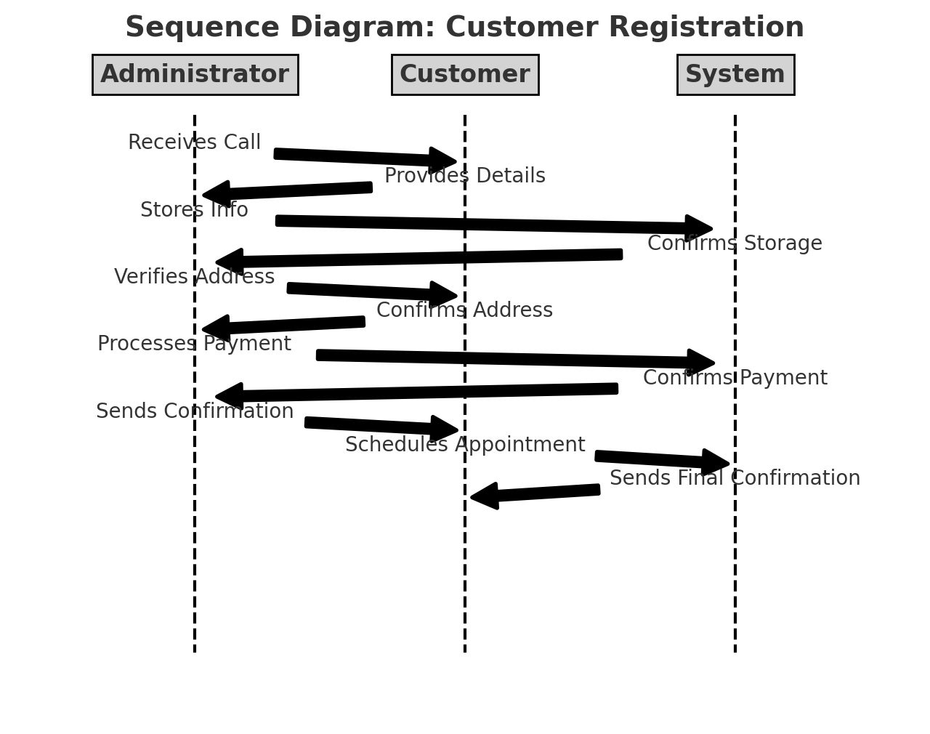

This diagram showcases the key entities in the DriverPass system, including **Users, Administrators, Customers, Lessons, and Packages**, along with their attributes and relationships.

### UML Class Diagram

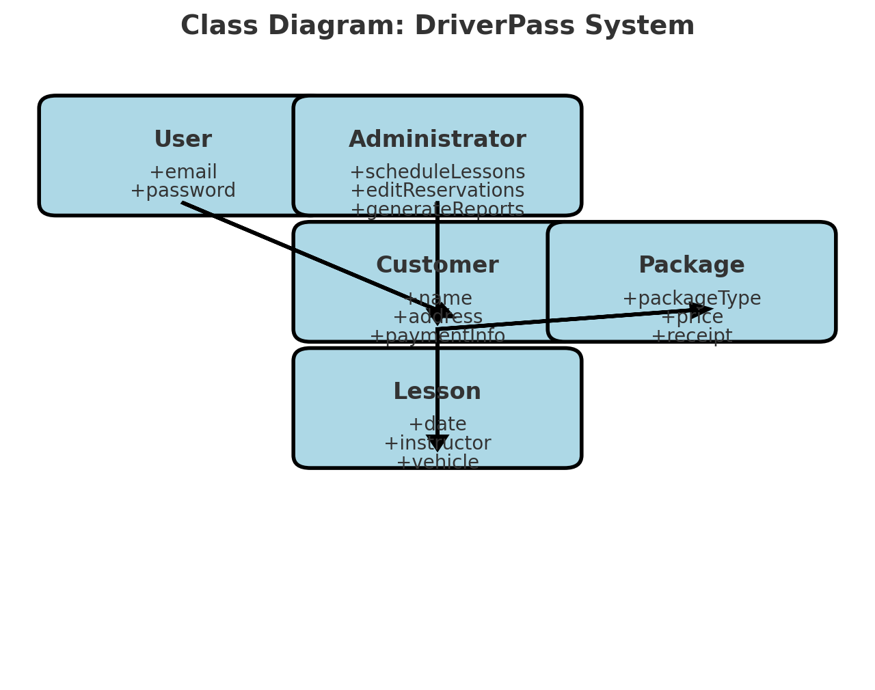

## Technical Requirements

**Technical Requirements**

**Hardware Requirements**

* **Server Infrastructure**: Cloud-based or dedicated on-premises server.
* **Client Devices**: Laptops, desktops, and mobile devices for user access.
* **Networking**: Reliable internet connectivity for seamless operations.

**Software Requirements**

* **Operating System**: Windows/Linux for backend, MacOS/Windows for client use.
* **Database Management**: PostgreSQL or MySQL for structured data storage.
* **Development Stack**:
  + **Backend**: Java Spring Boot or Python Django.
  + **Frontend**: Angular, React, or Vue.js.
  + **Web Server**: Nginx or Apache Tomcat.

**Tools & Infrastructure**

* **Development Tools**: Lucidchart for UML, Visual Studio Code for coding.
* **Cloud Services**: AWS or Google Cloud for scalability and security.
* **Security Measures**:
  + Role-based access control (RBAC).
  + SSL encryption for data security.
  + Automated backups for reliability.

This system ensures a structured and efficient way to manage driver lesson scheduling and administration, improving user experience and business operations.